Equestrian Tourism

An Introduction to the Scope and benefits

for economic development, and recreation

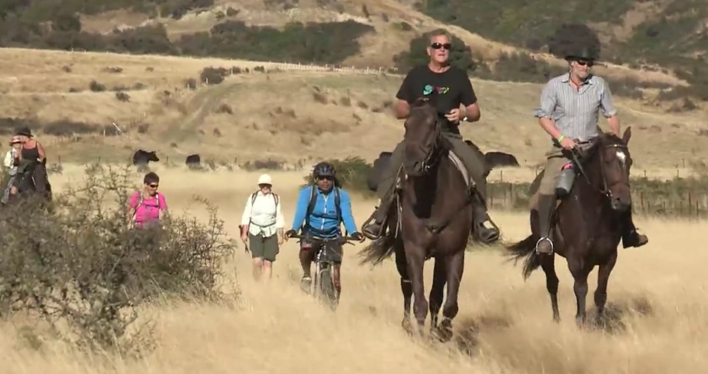

Photo credit - Great New Zealand Trek

Vivien Dostine

# What is Equestrian Tourism?

Equestrian tourism emerged in the 1950s in Europe, and especially in France[1]. Equestrian tourism can be defined as any travel related to the equine sector, and loosely grouped into[2]:

* **Events based tourism** – equestrians travelling to equestrian events, education, training, or shows
  + **Sport tourism** – a sub-set of events based tourism with some unique characteristics
* **Recreation tourism** – commonly referred to as horse trekking; but often, mistakenly, focuses solely on commercial horse trekking operators
* **Agribusiness Tourism** – stud, training centre or scientific centre visits

## How is equestrian tourism currently promoted?

### International Visitor promotion

The main tourism portal, newzealand.com, features “walking, and hiking” on the front page, but not cycling, nor horse riding. When searching for activities, “horse treks” are offered on the activities drop down, but these are only commercial horse trekking centres. Unlike cycling or walking, there is no mention of independent travel options, nor of horse trails or any other aspects of equestrian tourism.

Only walking and cycling trails are mentioned (along with kayaking, sailing or diving, and a host of ‘adventure’ sports) for those visitors interested in independent horse riding adventures – or for kiwis using this site to plan their own holidays.

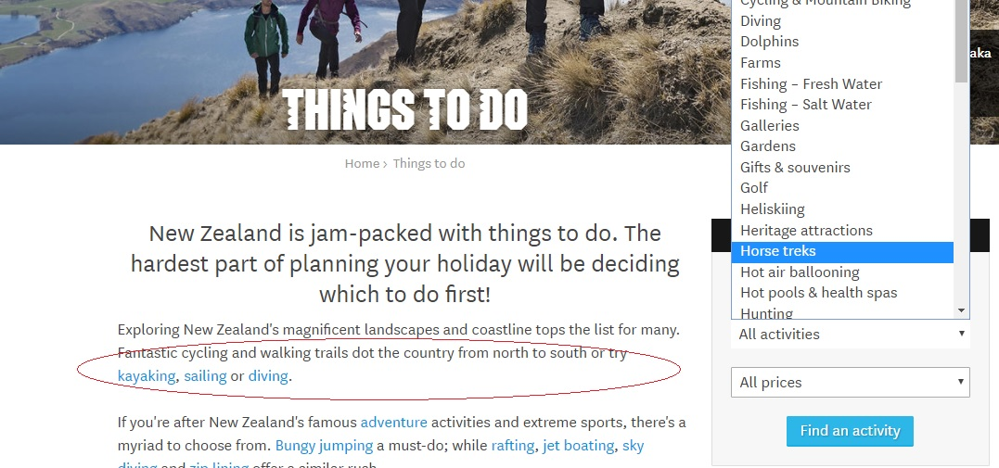

### Regional Tourism promotion

Many regions make promotional videos and adorn their websites with beautiful scenes of horse riders cantering down a long beach, or through natural settings. However, the falseness of the imagery is rather jarring to many local equestrians, who see the depictions of freedom to attract visitor dollars, in direct contrast to the restrictions on horse riding in that same region[3].

Queenstown, for instance, offers local horse trekking companies (essentially) advertising space on the official tourism website[4], but this is hidden under ‘scenic sightseeing’, and doesn’t appear at all in the “See & Do” options.

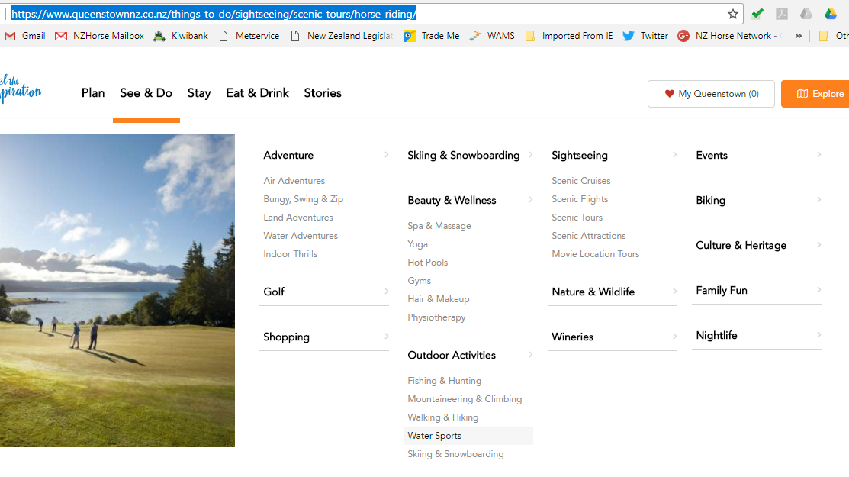

No information for independent equestrian visitors, and little on the local Council websites. Queenstown in fact, has been steadily removing equestrians traditional access to local routes e.g. horse riders were removed from trails that were turned into routes for cycleways.

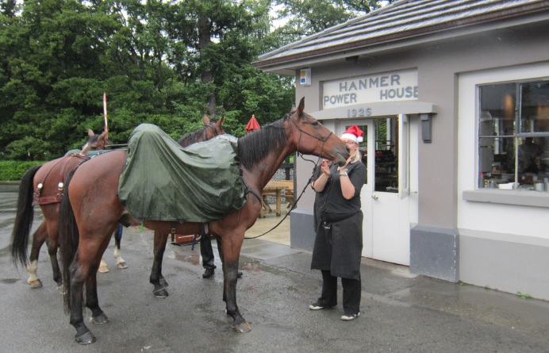

French woman Alex Cadet journeyed through much of New Zealand on horseback, but was less than impressed by the lack of access. Alex had previously travelled from France to Switzerland on horseback, and was not expecting such a sparsely populated country to have so many barriers. .

## The current New Zealand domestic tourism market

While equestrian tourism is not restricted to equestrians, (many non-equestrians enjoy horse trekking, or participating as spectators at shows, or events), it is helpful to understand the size of the domestic equestrian market.

In New Zealand there are approx 80,000[5] sporting, or recreational horses (outside the racing industry); around 100,000 equestrians[6] (people who ride on a regular basis). They spend approx, $1B annually[7] (outside of major capital expenditure), including on domestic tourism; visiting events, educational workshops (called clinics), and going on holiday with their horses.

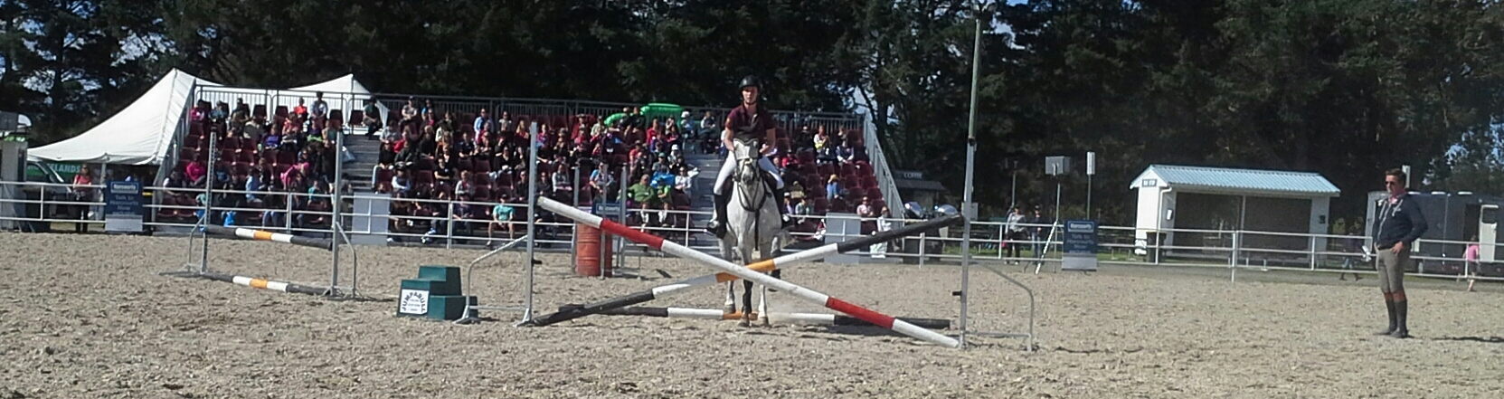  
Equidays, an equine version of Fieldays has been a great success in the few short years since its inception. However, Waikato does little to capitalise on this event.

### 

### Events based Equine Tourism

Equestrians love to travel to educational events, trade shows, and horse based entertainment, and these events also appeal to many people who are not current equestrians too! Annual events in NZ:

* NZ Horse of the Year Show - 6 days, 85,000 visitors, 2600 horses . $12.5 million economic benefit[8]
* Equidays[9] - 4 days, 24,000 visitors, 211 exhibitors, 312 competitiors (approx 1,000 horses)
* Equitana – 2017 first year in Auckland. *Equitana trade fair takes place in Essen, Germany and Kentucky, USA, Australia (Melbourne, Sydney or Brisbane), and in 2017 Auckland, New Zealand. In Essen the show covers 16 exhibition halls and a total area of 48,000m2, with one whole hall dedicated to riding holidays*

**Sport based tourism** – during the competition season, competitors and their support crews travel the nation. Horse friendly regions could easily capture more benefit from the influx, as largely they roll into the competition venue, and do not engage with the larger community (because there are no facilities to encourage them to do so).

### Recreation Tourism

* Trekking groups across the country organise treks (long and short) on private farmland, and in DOC land to meet the demand for recreational rides.
* Hunts, pony clubs and other sporting groups organise end of season treks, and camping adventures for their members (and to fundraise).
* Annual events such as Great New Zealand Trek[10], or Great New Zealand Trail ride cater for hundreds of riders, walkers and cyclists
* Individuals travel with their horses to various locations with horse trails, and camping or accommodation options.
* Commercial horse trekking – riders renting horses from horse trekking or farm stay operators.

### Agribusiness Tourism

Little is done in NZ regions to promote equine agribusiness tourism, but there are some small attempts

* Waikato throughbred stud tours, New Zealand Trotting Hall Of Fame Museum, Bulls Museum

## Regional Tourism Opportunities

While the official New Zealand tourism agency, and many regions promote themselves with scenes of horse riders on beaches, and open spaces there is little effort to tap into, or promote the domestic equestrian tourism, or recognise international visitors interest in independent horse travel.

Many regions are building cycle trails to lure visitors, as part of their economic development strategy, but if all regions offer the same thing, then the region with the ‘best’ natural assets, or, cheapest prices will surely ‘win’. Sadly by promoting these trails as ‘cycleways’, even the enormous walking market is discouraged from using these expensive regional assets.

### Public Trail Tourism

Trails, forests. beaches, DOC land and even quiet roads (with good verges) can provide excellent opportunities for horse riders. Horses prefer a natural surface (not rock), so trails just need a 1m wide grass strip to the side of any formed trail.

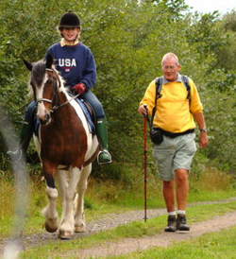If commercial horse trekking operators are limited to private land, then the benefits to local businesses are also limited i.e. lunch, and even accommodation will be supplied by the operator, not the local pub, or B&B. Such an arrangement also fails to provide for local recreation, or cater to independent equestrian tourism.

#### Benefits of Diversifying

During the GFC, equestrian tourism was the only market not in crisis according to Alessandro Silvestri, the president of Italian Equestrian Tourism Federation[11]. Diversifying revenue streams is economics 101!

* Walkers, and horse riders are slower on trails than cyclists, spending additional time on long trails, and therefore potentially spending more money on accommodation, food etc.

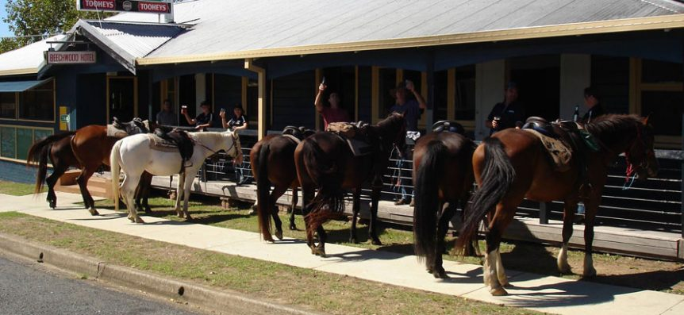horse trekking on public trails means more money for local businesses

* Horse riders pay extra to house and feed their horses, and require a different set of support services (farriers, horse transport, vets), providing different potential income streams to local businesses.
* Opening up existing trails (cycleways) to all visitors, whether on foot, on cycle, or on horseback is an easy way to increase the potential visitor base.
* It also enables families, and social groups with different preferences to recreate, or holiday together. It can also encourage repeat visits; trying different modes of travel to experience the same area, or trails, in different ways.

#### Extending events based revenue

Equine events should be being capitalised on by regional development teams. When equestrian competitions, or trade shows are scheduled, encourage competitors to stay a few extra nights, or come early, by promoting local riding opportunities, and encourage visitors to return for the trails and horse friendly facilities.

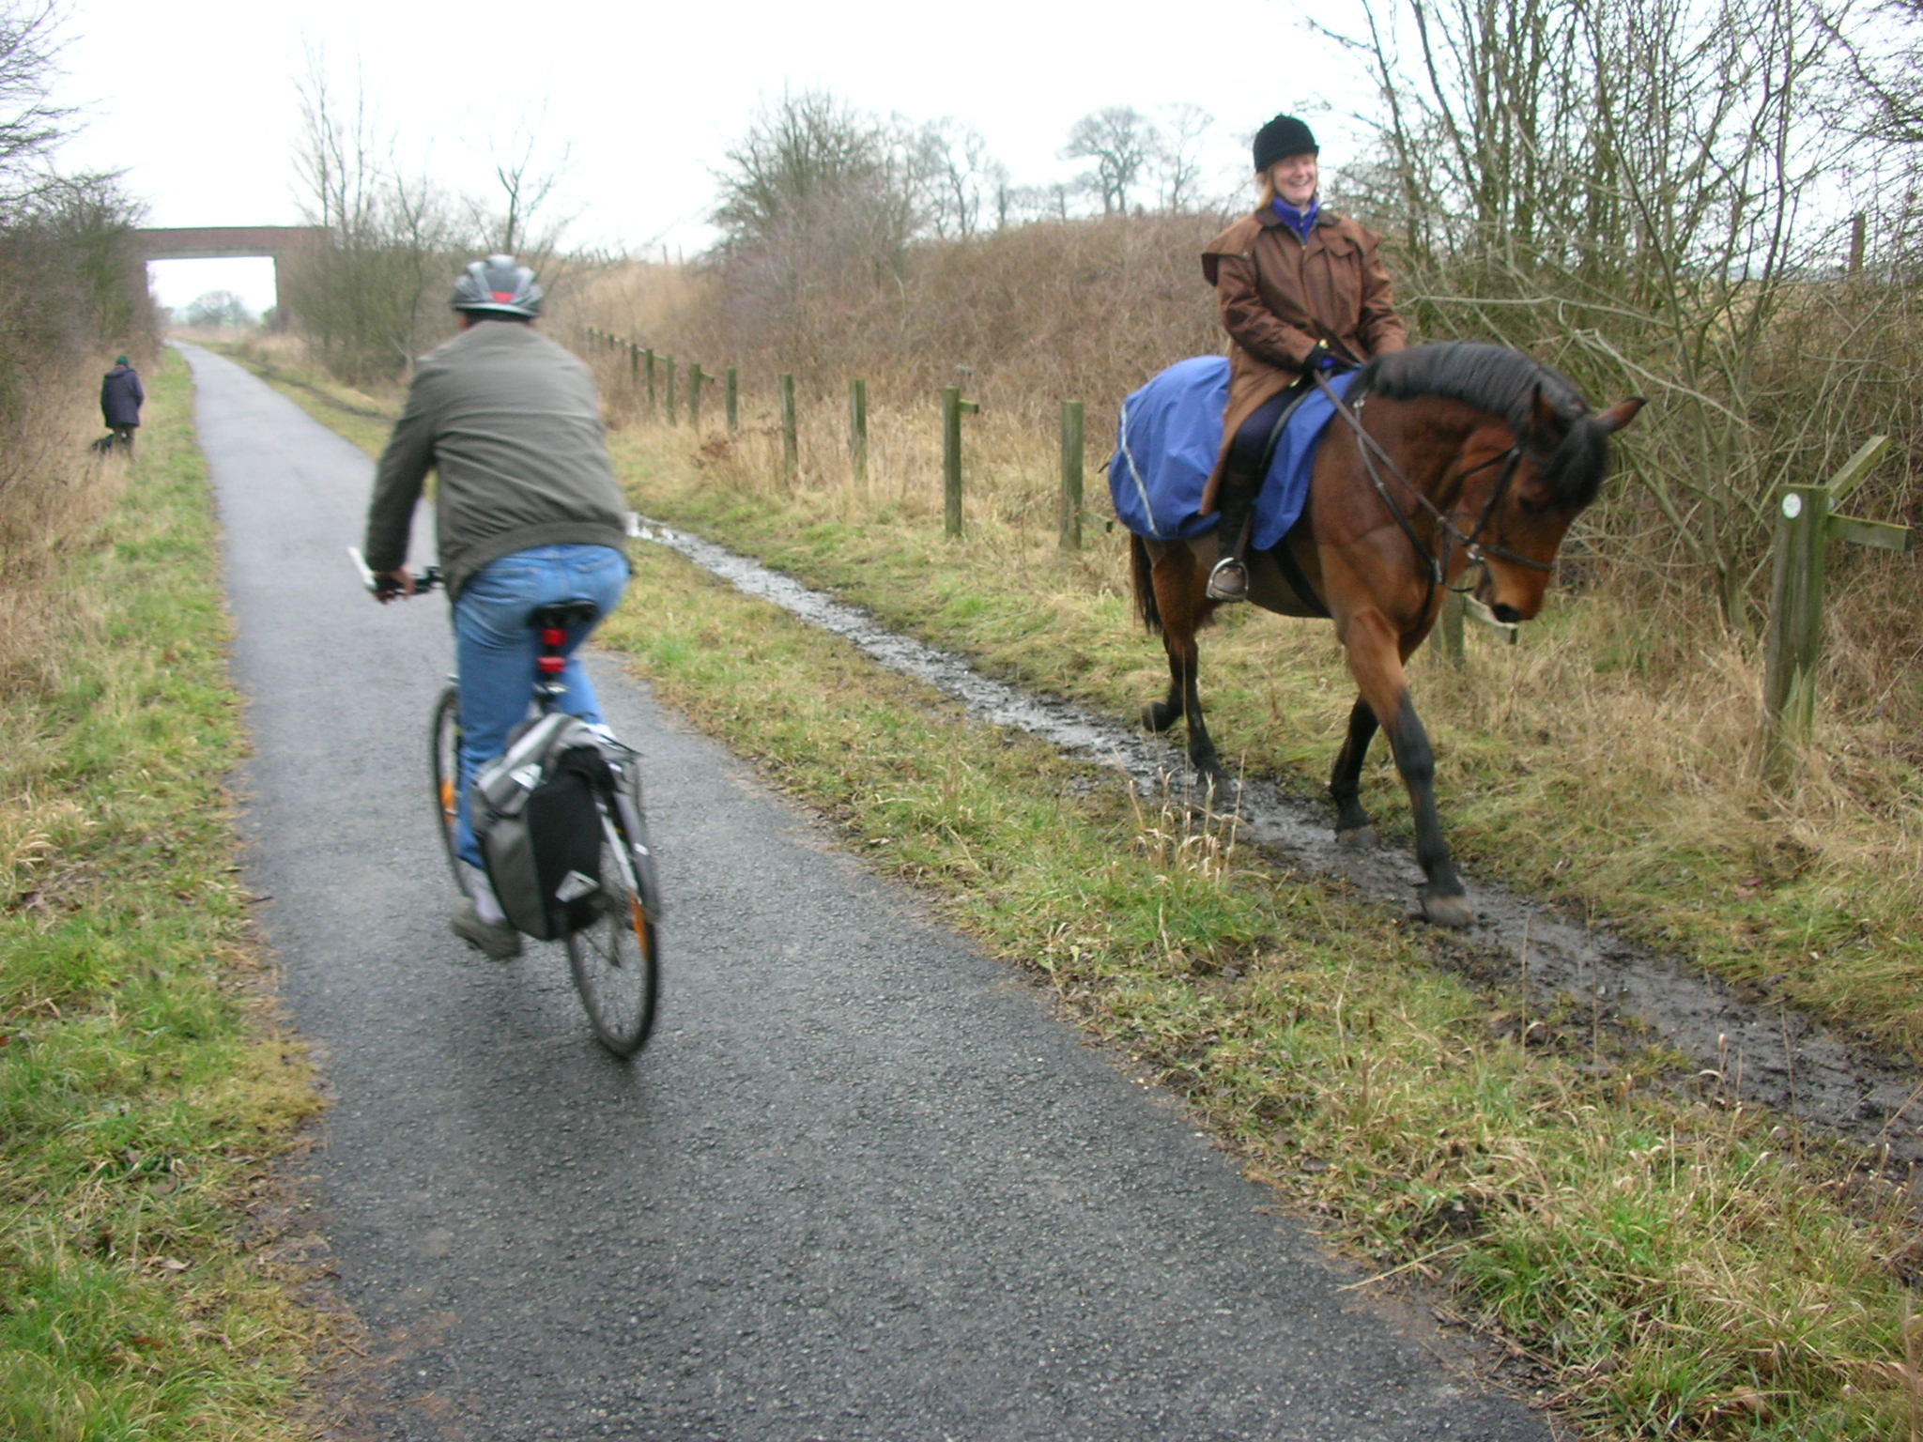  
Equestrians prefer not to have a trail tread where it can be avoided - natural grass and dirt are the best footing

## Equestrian Tourism Worldwide

*potential markets, and competitors*

Many international and domestic visitors who have never ridden a horse before enjoy horse riding while on vacation in New Zealand, and these are well catered for by horse trekking companies. However, it is important to understand the size of the equestrian sector worldwide, as equestrians may look for a different experience from the non-rider, including independent riding holidays.

New Zealand riders are also being enticed to spend on overseas riding holidays, rather than travelling to the regions due to the perceived lack of horse friendly opportunities.

There are over 30 specialist equestrian tourism operators in the UK and Europe, selling over 4000 horse riding package tours each year. Industry figures from Ireland indicate that package tours are vastly outnumbered by those who independently organise their equestrian holidays[12].

### United Kingdom[13]

* 3.5 million people (six percent of the GB population) have ridden a horse at least once in the past 12 months, 1.6 million people ride at least once a month.
* Indirect consumer expenditure associated with equestrian activity is estimated at £557 million
* The British Horse Society National Equestrian Route Network presently stands at 18,865km, while in Scotland all lands are accessible under the Land Reform (Scotland) Act 2003.
* There are over 18,000 active equestrian businesses in Great Britain.

### Europe[14] [15]

* Europe has 30 million equestrian tourists. In Italy, there are 1.5 million of equestrian travellers
* Germany has the largest horse populations in the European Union. Sweden has the greatest number of horses per capita, Belgium and the Netherlands the highest density of horses per ha.
* France is the biggest horse riding country in Europe,:
  + 1m+ riders. 90,000 members of the French National Horse Riding Federation (representing 2500 horse-riding centres and riders' associations) and
  + 1600 businesses specializing in equestrian tourism (and/or stabling), and 60,000 km trails
  + Horse riding and equestrian tourism have been promoted by official bodies (National Resource Center for Outdoor Sports; French Equestrian Federation) as an important agent for sustainable development.
* Germans make the most equestrian based trips abroad.
* Countries such as France and Hungary have recognized the economic potential of equestrian tourism and government agencies promote this segment of the tourism market and provide it with higher standards (Association of Hungarian Equestrian Tourism and National Committee for Equestrian Tourism France).

### How the European regions promote equestrian tourism

Throughout Europe and the UK it is perfectly normal to share trails, and to have high level support for this important market.

* **Denmark**, is known for cycling, but it doesn’t assume that other activities are less of a priority. It is an extremely horse friendly country, and regional tourism sites promote many activities. Horse riding features as prominently as cycle touring, and share many of the same routes..
  + **Top of Denmark** tourism not only has an app for horse riders to find routes, and accommodation, but a specific section of the Danish Tourism website caters to horse riding. Importantly the focus is on welcoming riders, and giving them the experience they are looking for. [View the "Toppen af Danmark" regional website on "Visit Denmark](http://www.skagen-tourist.dk/ln-int/toppenafdanmark/riding-top-denmark)”
  + **North Sea** [View the website here](http://www.hvidesande.com/ln-int/hvide-sande/riding-north-sea-and-fjord)
* **Italy** - “Visit Tuscany” regional tourism. [Visit Tuscany - Discover on Horseback](https://www.visittuscany.com/en/ideas/discover-tuscany-on-horseback/)  focuses first on the horse trails available in the area. The Amiata trail, for example, is a shared route <http://unseentuscany.com/mount-amiata-hike-bike-and-ride/>

#### **EUquus Project**

EUquus is a European project co-financed by the Innovation and Competitiveness framework programme with the aim of developing and diversifying equestrian tourism. It is part of a sustainable development process seeking to boost tourism in rural areas, and pursues a dual objective:

* the set-up of an EUquus label in order to improve the quality of equestrian tourism routes in Europe,
* the roll-out of a web platform to disseminate and promote European equestrian tourism offerings.

 The partnership includes public and private organizations from 6 countries:

* Diputació de Barcelona - Barcelona Provincial Council (Spain), is also a leading partner, Fundació DEST Menorca (Spain),
* the Chambre d'Agriculture de la Dordogne (France),
* Far and Ride Ltd. (United Kingdom), Only Raid SL (Spain),
* Faculty of Tourism and Hospitality Management (Croatia),
* Herd Ogierów Sieraków (Poland),
* Provincia di Salerno (Italy),
* Hushållningsällskapet Östergötland (Sweden).

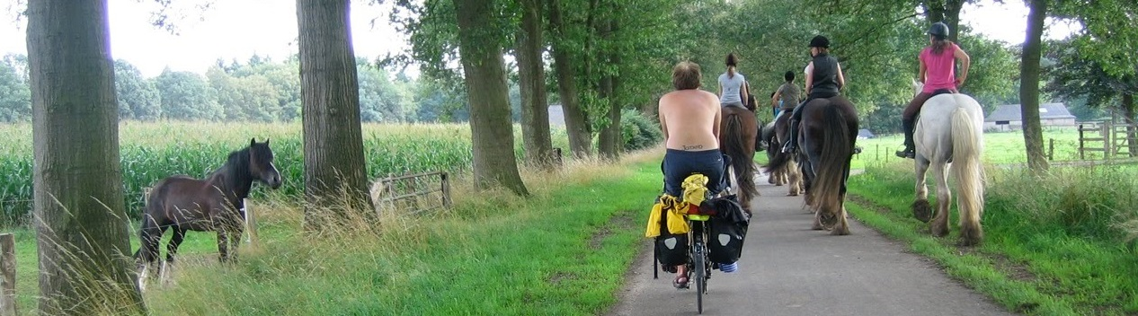

## North America[16]

The 39 billion dollar[17] equine market is an integral part of the United States’ economy, and the equine market also contributes a significant $12.5B to the Canadian economy.

* USA - 9.2 million horses[18], 2m horse owners, 7.1 million people involved in equine industry

National, and state parks in the USA commonly have horse camping sites, encouraging domestic equestrian tourism. Major multi-day trails such as the Pacific Crest Trail[19], and Trans Canadian Trail (The Great Trail)[20] provide aspirational journeys, as well as regular recreation for the communities they go through.

**Kentucky tourism[21]** actively markets itself as a horse racing capital of the world, and uses the tagline “unbridled spirit” along with a horse logo. But it doesn’t just rely on horse racing, offering visiting equestrians many camping, and riding opportunities – on hired horses, or bringing their own.

### The new equestrian markets: Asia

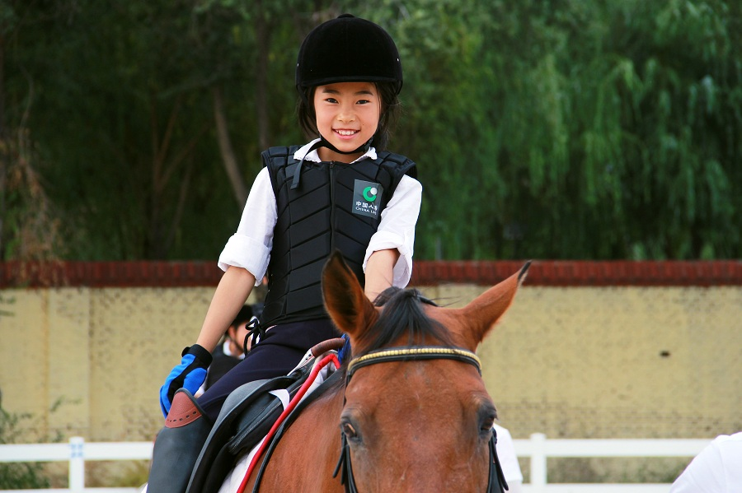Both India and China have a long history associated with the horse, and as an affluent middle class emerge, so does an interest in equestrian sport, and recreation.

Korea (both North and South), Japan, and Malaysia, Singapore also have a thriving equestrian scene.

End Notes

1. Fédération Internationale de Tourisme Equestre (FITE) https://en.fite-net.org/Equestrian-tourism
2. This report does not include horse racing per se i.e. visitors attending race meetings
3. A recent Taranaki promotion showed horse riders on Taranki beaches, yet local bylaws prohibit riders on beaches in summer
4. Queenstown Tourism website https://www.queenstownnz.co.nz/things-to-do/sightseeing/scenic-tours/horse-riding/
5. Agribase (2009)
6. Sport NZ Active New Zealand Survey (Adults) + Young Persons Survey
7. NZ Horse Network Equine Economic ttp://www.nzhorseriders.info/projects/projects/theequestrianeconomy
8. Hawke's Bay Today $12.5m horse show in Bay for next 12 years http://www.nzherald.co.nz/hawkes-bay-today/news/article.cfm?c_id=1503462&objectid=11422283
9. Equidays Statistics from 2017 Prospectus http://equidays.co.nz/wp-content/uploads/2017/04/Equidays-Prospectus-2017-Web.pdf
10. The Great New Zealand Trek https://www.greatnewzealandtrek.org.nz/
11. Tourism Review: Weekly Travel News “Equestrian Tourism In Italy Calls For Intensive Promotion” (2013) https://www.tourism-review.com/italy-equestrian-tourism-plans-intensive-promotion-news3871
12. Profile of overseas visitors participating in equestrian activities in 2011 http://www.failteireland.ie/FailteIreland/media/WebsiteStructure/Documents/3_Research_Insights/1_Sectoral_SurveysReports/Equestrian_tourism_in_Ireland_2011.pdf?ext=.pdf
13. "Equestrian Statistics", British Horse Society, (2013) , http://www.bhs.org.uk/our-charity/press-centre/equestrian-statistics
14. "Horse Riding in Europe, Euquus (2014) http://professional.euquus.eu/sites/euquus.eu/files/study_of_the_equestrian_tourism_in_europe_2013-2014.pdf
15. Can equestrian tourism be a solution for sustainable tourism development in France?, Silvine Pickel-Chevalier, Loisir et Société / Society and Leisure, Volume 38, 2015 - Issue 1
16. The Equine Industry As A Global Market, Connors. S, Feldman. L, (2009) https://www.researchgate.net/publication/276830364_The_Equine_Industry_as_a_Global_Market
17. The American Horse Council’s 2005 report brings this number to an overall impact of $102 billion when including direct, indirect and induced effects. Including direct, indirect and induced effects are included. (<http://www.horsecouncil.org/nationaleconomics.php>)
18. American Horse Council stats http://www.horsecouncil.org/economics/
19. Pacfic Crest Trail - 2,650 miles (4,265 kilometers) from Mexico to Canada  https://www.pcta.org/discover-the-trail/
20. The Great Trail, Canada 24,000km - hike, cycle, paddle, ride, cross-country ski or snowmobile across the entire Canadian continent.
21. Kentucky Tourism https://www.kentuckytourism.com/things_to_do/horses.aspx